Multiple year stock data

2018

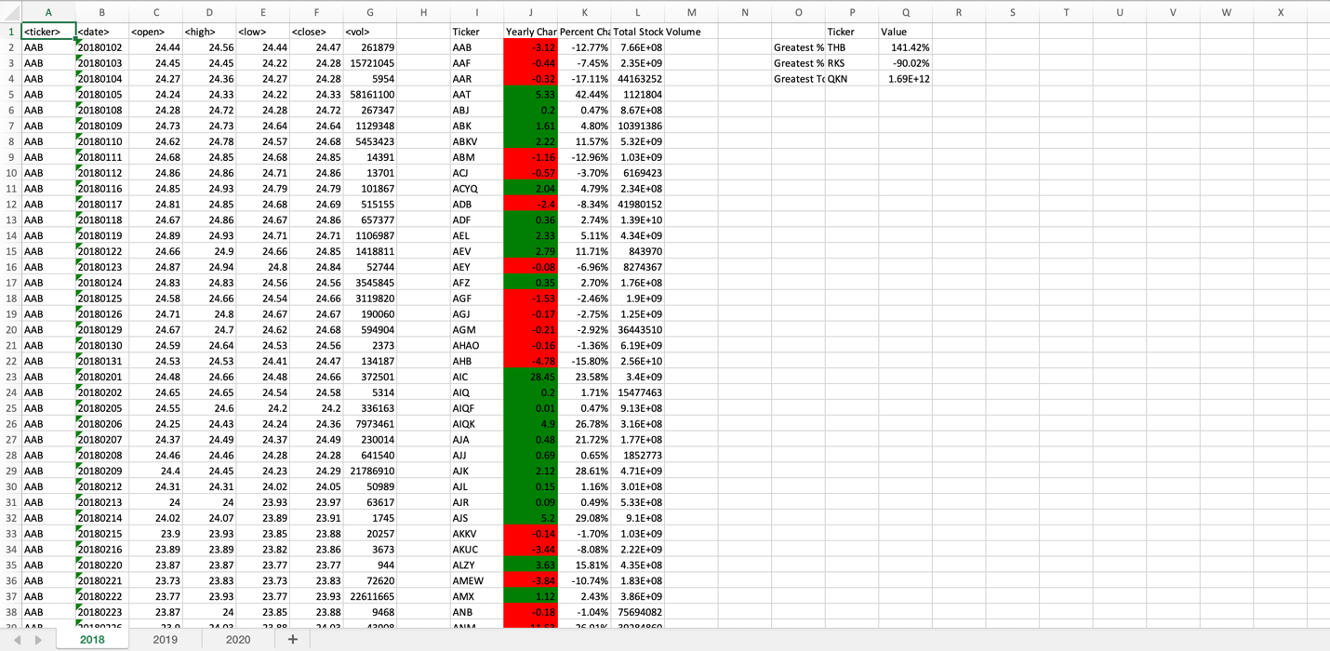

2019

2020

